DoD Civilian Acquisition Workforce Personnel Demonstration Project

Employee Orientation Course
2010 - 2011

Table of Contents

Chapter 1: AcqDemo Conversion Highlights 6
AcqDemo Purpose 6
Terminology Crosswalk 7
GS to AcqDemo Classification Conversion 8
Broadbands 8
Conversion Pay Setting 9
Position Requirements Documents (PRD) 11
Maximum Broadband Level 12
Chapter 2: Participating Organization Management Structure 13
Organization Management Structure Decisions 14
Chapter 3: Pay Administration Considerations 15
Compensation Management 16
Compensation Philosophy 17
Compensation Strategy 18
Control Points / Stop-and-Consider Points 19
Compensation Strategy Business Rules Decisions 20
Compensation Policy 21
Highest Previous Rate 22
Supervisor and Team Leader Cash Differentials 23
Accelerated Compensation for Developmental Positions (ACDP) 24
Retained Pay Compensation Option 26
Performance Awards 27
Pay Administration Considerations Business Rules Decisions 28
Chapter 4: Contribution-Based Compensation and Appraisal System (CCAS) Considerations 29
CCAS Design Overview 30
Key Terms 30
CCAS Cycle 31
Contribution Planning 31
Employee Self- and Supervisor Assessments 34
Scoring 36
Very High Score 37
Contribution Planning, Employee Self- and Supervisor Assessments, and Scoring Business Rules Decisions 38
Pay Pool Funding 39
Discretionary Set-Aside 40
CCAS Reward Payout Criteria 41
Selecting Target Pay 42
CRI Carryover 45
Pay Pool Funding Business Rules Considerations 46
Quality of Performance 47
Quality of Performance Level Definitions 48
Quality of Performance Level Values 49
CCAS Grievance Process 50
Quality of Performance and Grievance Process Business Rules Decisions 51
Communicating Aggregate CCAS Results 52
Continual Feedback and Mid-Point Review 53
Closeout Assessments 54
Communication and Feedback Business Rules Decisions 55

Welcome to the AcqDemo Business Rules Development one-day class.

The purpose of the Department of Defense Civilian Acquisition Workforce Personnel Demonstration Project (AcqDemo) is to demonstrate that the effectiveness of DoD acquisition can be enhanced by allowing greater managerial control over personnel processes and functions and, at the same time, expand the opportunities available to employees through a more responsive and flexible personnel system.

This training session is designed for management personnel to understand the requirements of their AcqDemo business rules so as to begin developing policies needed for implementation.

Chapter 1: AcqDemo Conversion Highlights

AcqDemo Purpose
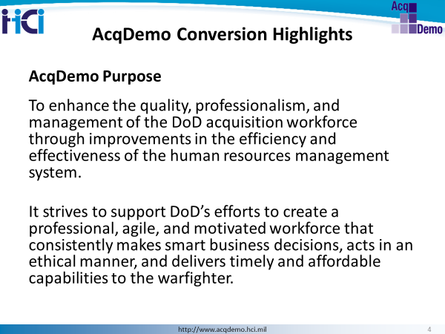
NOTES:

Terminology Crosswalk

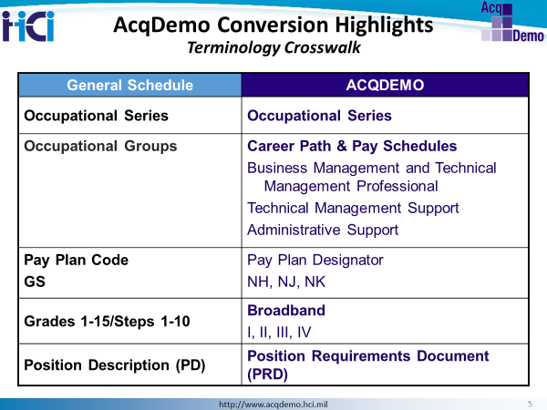

Here we have the key terminology differences between the classification structure of GS and AcqDemo.
In GS, similar series were grouped together in a career group, e.g. Accounting & Budget Group (0500), Business & Industry Group (1100), etc., and then pay set under the GS or other pay schedules for different possibilities. Under AcqDemo, occupational series are grouped more by the role they play…business professional, technical management support and administrative support.
Our pay schedules have a one to one relationship with each of these career paths, NH to management, NJ to technical support and NK to admin support. AcqDemo pay schedules do not provide for a different supervisory pay schedule, though the program does have a supervisor/team lead cash differential feature.
AcqDemo career paths contain 3-4 broadband levels.
Finally, your job description in AcqDemo is called a Position Requirements Document.
This chart shows a crosswalk of classification terminology from GS to AcqDemo. The architecture of AcqDemo is simplified and designed specific to the acquisition workforce.

GS to AcqDemo Classification Conversion
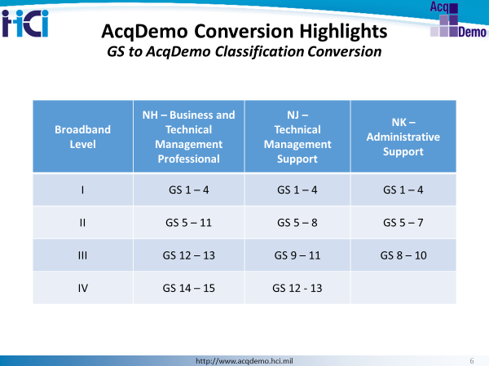
The classification conversion process is automated based on the above criteria.

Broadbands
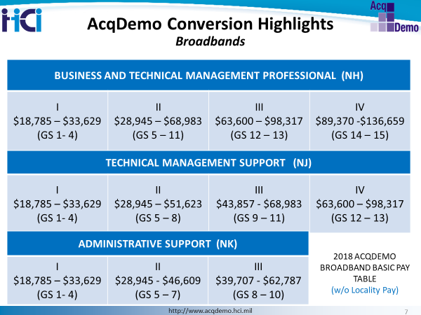
This chart provides a visual of the AcqDemo career paths, broadband levels and their associated basic pay ranges, along with the GS equivalents for reference.

Conversion Pay Setting
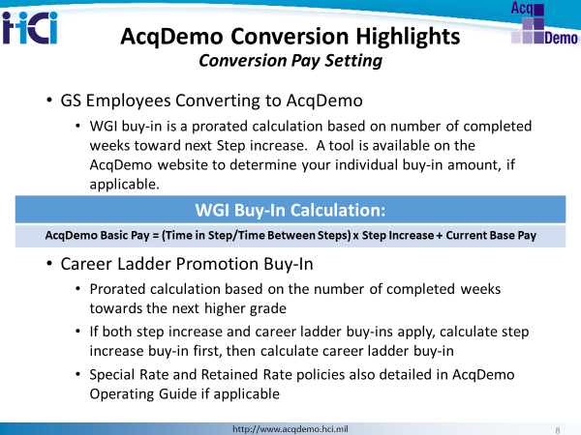
Within-Grade Increase (WGI) buy-in option is only available if hiring from a graded position in a pay system that offers WGIs or equivalent.
Operating Procedures Reference:
2.10.1.1 Buy-ins
WGIs inherent in the GS system are discontinued under this demonstration project. In order to compensate employees equitably at the time of their organization’s initial conversion into AcqDemo, adjustments to the employees’ basic pay for a step increase and/or non-competitive career ladder promotion will be made. This process is known as a “buy-in.”
2.10.1.2 Calculation
Specifically, “buy-in” adjustments to an employee’s basic pay for a step increase and/or a non-competitive career ladder promotion will be computed based on the organization’s implementation date, according to a prorated share computed upon the number of weeks an employee has completed towards the next higher step or grade. A week is considered to be in effect at 0001 hours on each Sunday.

2.10.1.3 Eligibility
Employees will not be eligible for the WGI buy-in if their current rating of record is unacceptable at the time of conversion, are at step 10, or are receiving retained pay at the time of conversion will not be eligible for a WGI buy-in. An employee on retained pay whose basic pay exceeds the maximum basic pay of the broadband level (as determined by the employee’s grade) is not eligible for a buy-in adjustment. As such, an employee’s rate of basic pay remains the same under AcqDemo as it was previously. Employees on retained grade at the time of conversion into AcqDemo will receive a "buy-in" for their within-grade increase provided they would have received a WGI prior to expiration of their retained grade. Their basic pay will then be set at that rate in the career path and broadband level for their position of record. Employees on grade retention at the time of conversion transition into AcqDemo who would not receive a WGI prior to expiration of their grade retention will not receive a buy-in for their WGI. Their basic pay will be set at the rate in the broadband for their position of record. Employees whose pay exceeds the top rate of the broadband level will have their pay retained.
2.10.2 Career Ladder Promotions
Similar computation applies for career ladder promotion buy-in. If both the step increase and the career ladder buy-in apply, calculate the step increase buy-in first, and then calculate the career ladder buy-in. For employees whose special rate exceeds their locality rate, the pay conversion will be processed first to derive a new rate of basic pay under the demonstration. Next, the WGI/career ladder promotion buy-in adjustment is added to the new rate. (This processing sequence is significant because it yields a higher rate of basic pay under the demonstration than the reverse sequence would.)
2.10.2.1 Career Ladder promotion buy-in may cause an employee’s rate of basic pay under the demonstration project to exceed the top of the broadband level corresponding to the employee’s pre-demonstration project permanent grade. If the employee’s rate of basic pay exceeds the maximum rate of basic pay for the broadband level containing the employee’s GS grade, the employee will remain at that broadband level and will receive a retained rate
2.10.2.2 For employees on career ladder positions, no within-grade increase (WGI) equity adjustment will be made if the employee’s basic pay is adjusted for a promotion that would be effective before the next scheduled WGI.

Position Requirements Documents (PRD)
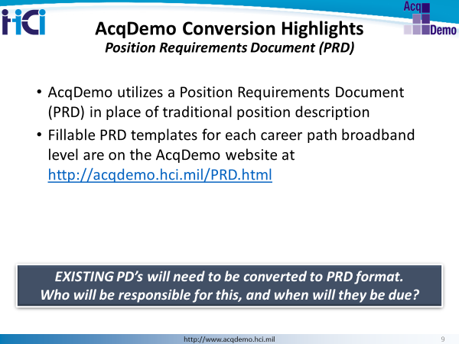
AcqDemo utilizes a Position Requirements Document (PRD) in place of a Position Description. Under the demonstration project’s classification system, a position requirements document (PRD) combines the position information; staffing requirements; factors, descriptors, and discriminators; expected contribution criteria for the assigned broadband level; and position evaluation statement into a single document.
This normally requires preparation of a new PRD for each position at the time of conversion to AcqDemo. Fillable templates have been developed for each career path and broadband and may be used in conjunction with a participating organization’s PRDs as determined by the participating organization.
The objectives in developing the PRD are to: (a) Simplify the descriptions and the preparation process through automation; (b) provide more flexibility in work assignments; and (c) provide a more useful tool for other functions of personnel management, e.g., recruitment, assessment of contribution, employee development, and reduction in force.

Maximum Broadband Level
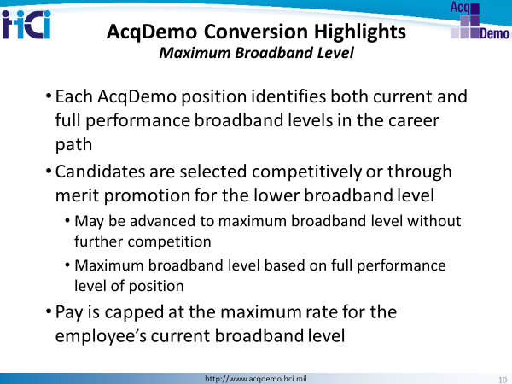
Federal Register notice, Section II.A.7 and Operating Guide, Chapter 3, paragraph 3.8.
- Commonly known as “target grade” or “full-performance level” under the General Schedule.
- Each position under the demonstration project has a designated maximum broadband level.
- This maximum broadband level will be identified as the top broadband level within a career path for a particular position and the broadband level to which an incumbent, selected competitively or through merit promotion for a lower broadband level, may be advanced without further competition.
- These broadband levels will be based upon the full performance levels of positions before conversion into AcqDemo. After conversion a newly created or re-described AcqDemo position may be assigned a different maximum broadband level based on the AcqDemo organization’s position management structure, change in mission, reorganization, and similar factors.
- Maximum broadband levels may vary based upon occupation or career path. An employee’s base pay will be capped at the maximum rate for the current broadband level until the employee has been promoted into the next higher broadband level.

Chapter 2: Participating Organization Management Structure
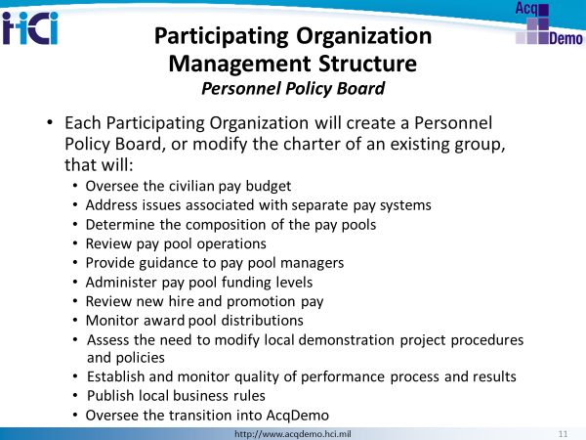
Each participating DoD activity is required to establish a Personnel Policy Board (PPB) for the demonstration project, or modify the charter of an existing group. This Board will consist of the senior civilian in each major office and directorate within the activity and be chaired by the Commander/Director. The PPB’s areas of responsibility are listed above.

Organization Management Structure Decisions
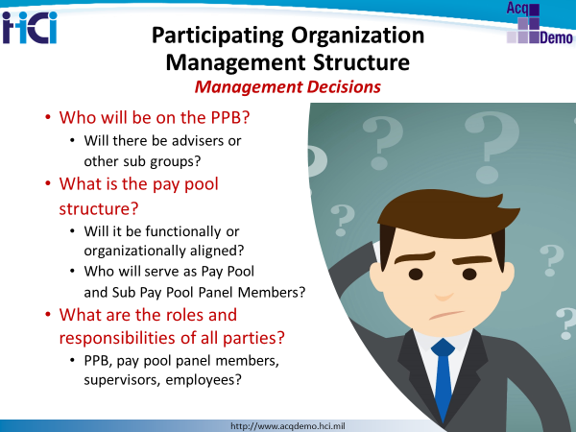
NOTES:

Chapter 3: Pay Administration Considerations
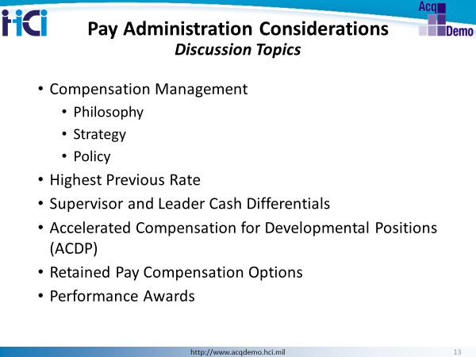

Compensation Management
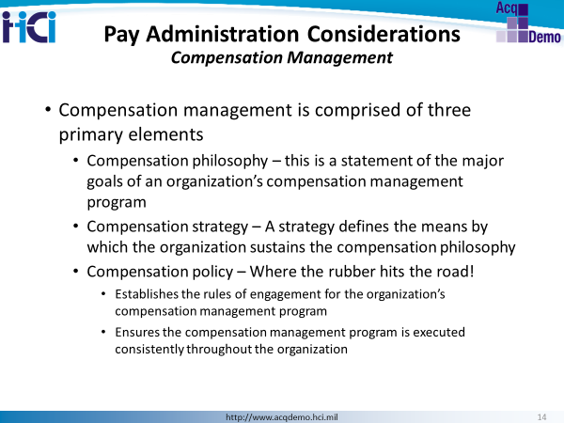
The Compensation Strategy is one of the most important strategies in an organization since it influences the costs of the organization and can significantly impact mission achievement. Poor decisions can lead to serious budgetary issues for the organization.
The main objective of a compensation strategy is to give the right rewards for the right employee contributions. Achievement of the desired contributions is, of course, important in order to enhance your organization's effectiveness. Compensation is a key motivator when it rewards achievement of desired organizational results. The compensation strategy must also support fulfillment of the organization’s budgetary constraints.
The compensation strategy not only sets the general rules for compensation within the organization, it is also a significant component in determining organizational goals. An organization could, for example, wish to set pay at the lowest possible levels. However, the organization has to respect the reality of the job market and, by doing so, may need to rethink its compensation strategy in order to most effectively and efficiently reach organizational goals.
The compensation strategy can also help to reinforce the organizational culture that you desire. There is an enabling organizational culture under which pay is linked to performance and contribution. For example, the role of bonuses can be primarily in rewarding actual contributions or the retention of the employees. Either way the organization decides, supervisors and pay pools must enforce the decisions.

Compensation Philosophy
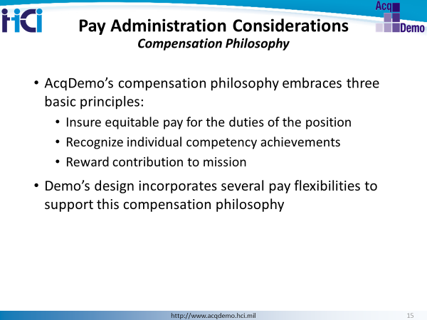
Federal Register notice, Section C.1., Introduction
AcqDemo’s compensation philosophy insures equitable pay for the duties of the position, recognizes individual competency achievements, and rewards contribution to mission.
To assist in this endeavor, AcqDemo provides a number of interventions and policies for special situations such as pay setting for new hires, reinstatement eligibles, and non-AcqDemo Federal civilian employees voluntarily accepting an AcqDemo position; promotions; buy-ins on voluntary permanent lateral transfers, reassignments, and realignments into AcqDemo; changes to lower career path, broadband level, and/or basic pay; supervisory and team leader cash differentials; accelerated compensation for developmental positions; and a contribution-based compensation system that aligns employees’ pay to their contributions to the organization’s mission and to the scope, difficulty, and value of their positions.

Compensation Strategy
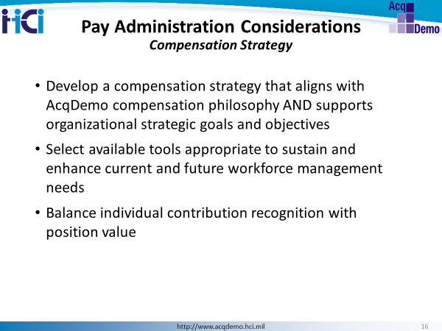
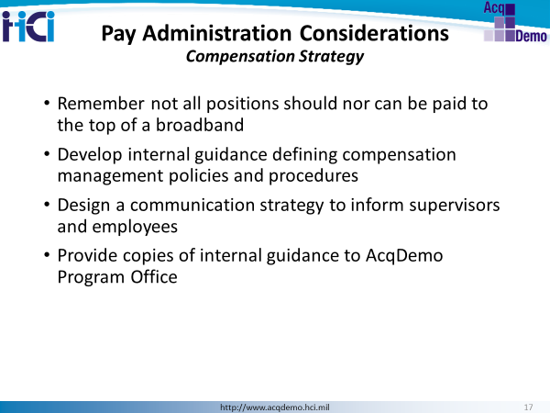

Control Points / Stop-and-Consider Points
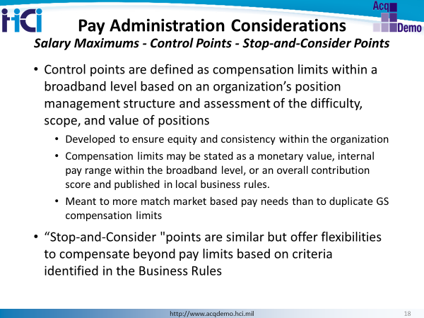
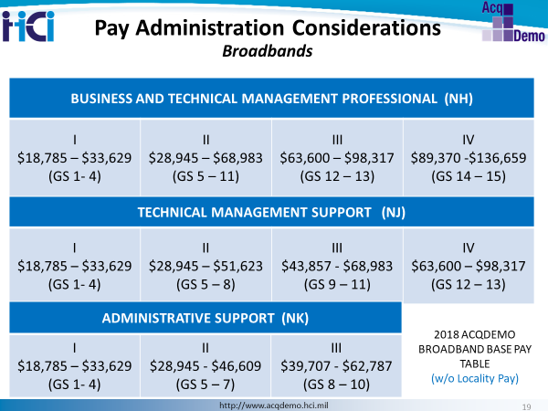

Compensation Strategy Business Rules Decisions
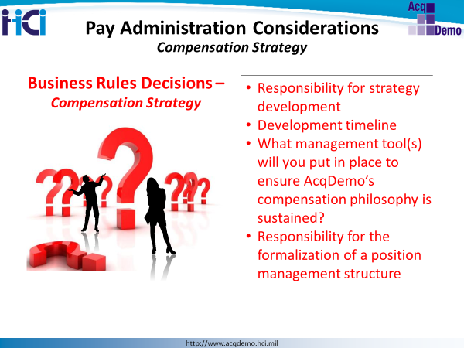
NOTES:

Compensation Policy
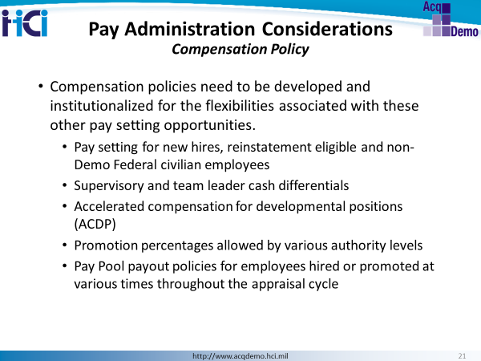

Highest Previous Rate
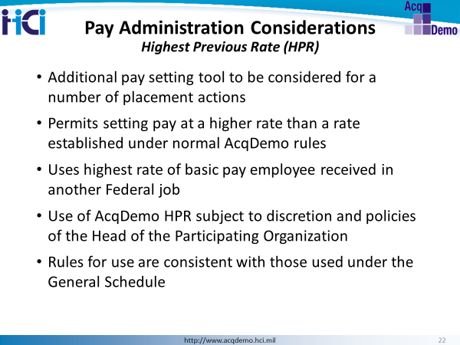
AcqDemo HPR allows an organization to set pay for an AcqDemo employee at a rate above the rate that would be established using normal AcqDemo rules, based on a higher rate of basic pay the employee received previously in another Federal job.
The AcqDemo HPR may be used for reemployment, transfer, reassignment, promotion, demotion, change in type of appointment, termination of a critical position pay authority under 5 CFR part 535, movement from a non-GS pay system, or termination of grade or pay retention under 5 CFR part 536.
Use of AcqDemo HPR will be at the discretion of the Head of the Participating Organization and subject to policies established by the organization’s senior leaders and/or Personnel Policy Board.
Careful consideration must be exercised when choosing to apply the AcqDemo HPR rule to ensure the integrity of the organization’s position management structure and maintain equity among positions performing like work. Using a highest previous rate may also set unrealistic contribution expectations for the position since the expected overall contribution score (EOCS) is based on current basic pay.

Supervisor and Team Leader Cash Differentials
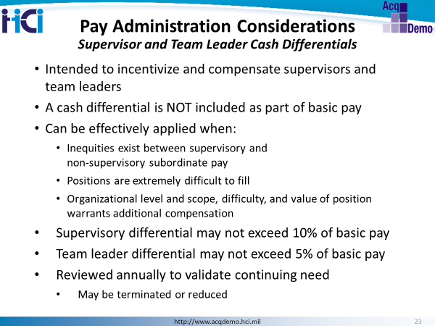
In many organizations, going from a non-supervisory role to a supervisory role occurred in GS as a change from a GS-12 to a GS-13. As both of those positions in the NH Career Path are NH-III positions, there was no opportunity to monetarily incentivize an employee with a base pay increase at the time of position change, only at the time of CCAS payout each January. This feature allows for an increase in pay at the time of position change.
A cash differential is not paid from pay pool funds and is NOT included as part of basic pay for entitlement calculations (e.g., retirement and Thrift Savings Plan); and is subject to the total aggregate limitation on pay. Because it is not part of basic pay, supervisors or team leaders who are at the maximum basic pay for their respective broadband level may still receive a supervisory cash differential.
It is paid on a pay period basis with a specified not to exceed date of one year or less; reviewed every year at the same time as the CCAS annual assessment and may be terminated or reduced as dictated by fiscal limitations, changes in assignment or scope of work, and/or an employee’s removal from the supervisory or team leader position regardless of cause. Termination or reduction of a cash differential is not an adverse action and is not subject to appeal or grievance.
A signed statement by an employee receiving a cash differential acknowledging all of the stipulations will be required.
The cash differentials are not automatic by virtue of holding a supervisory or team leader position. They will be used selectively, not routinely, to compensate only those supervisors and/or team leaders who fully meet the criteria.

Accelerated Compensation for Developmental Positions (ACDP)
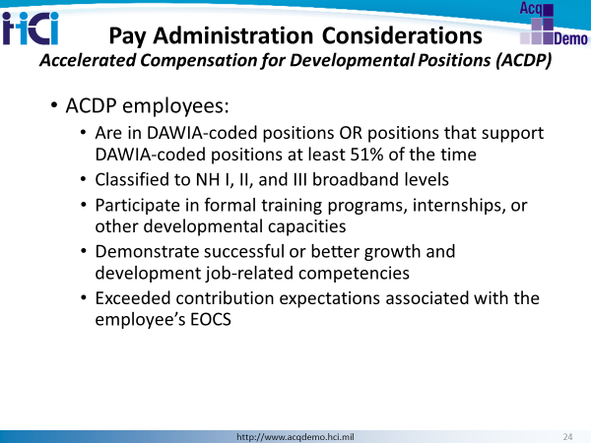

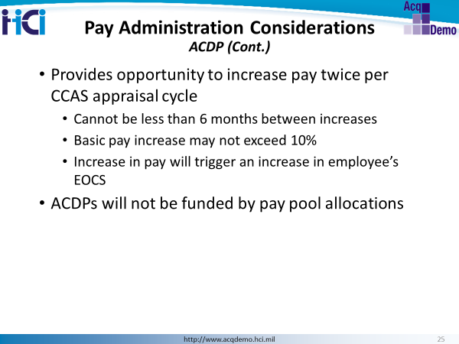

Often the term Career Ladder Position is used for these types of appointments. Employees are guaranteed increases at the time certain milestones are met (often an anniversary date).
Standards by which ACDP increases will be provided and development criteria by which additional basic pay increases may be given will be established in combination with the CCAS and documented in internal business rules, policies, and procedures.
The amount of the ACDP increase may not cause the employee’s basic pay to exceed the top of the employee’s broadband level, the target pay for the employee’s maximum broadband level, or compensation strategy set by internal business rules, policies, or procedures for both the position’s value and employee contributions.
A general O&M budget allocation or equivalent for civilian salaries, as appropriate, would be used to cover ACDP basic pay increases. If approved, Defense Acquisition Workforce Development Funds (DAWDF) may be an additional source of funds for ACDPs.

Retained Pay Compensation Option
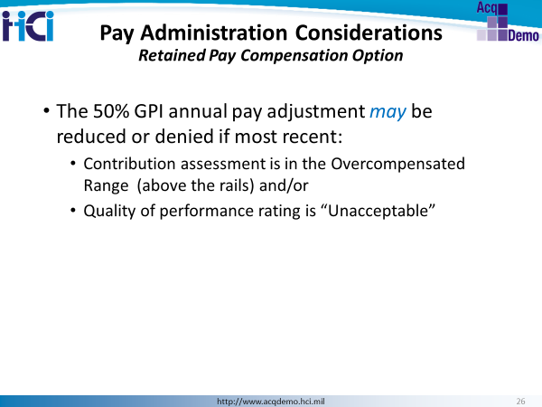
Pay retention provisions provide that an employee on pay retention whose most recent annual or interim (contribution-based action) assessment is Level 1- Unacceptable may have the 50 percent of the amount of the increase in maximum rate of basic pay payable for the broadband level of the employee’s position reduced denied or given in full.

Performance Awards
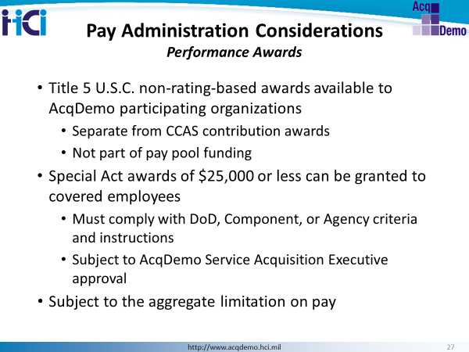
To provide additional flexibility in motivating and rewarding individuals and groups, some portion of the performance award budget will be reserved for special acts and other categories as they occur. Awards may include, but are not limited to, special acts, patents, invention awards, suggestions, and on-the-spot. The funds available to be used for traditional title 5 U.S.C. awards are separately allocated within the constraints of the organization’s budget in the CCAS funding pools (minimum of 10% of CA award money must be set aside for cash awards given throughout the CCAS appraisal cycle).

Pay Administration Considerations Business Rules Decisions
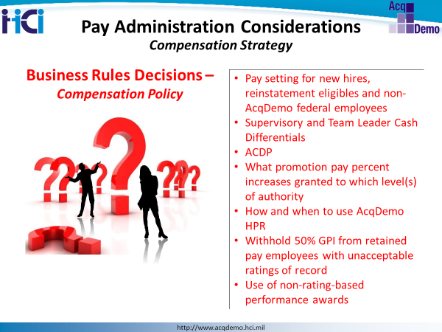\
NOTES:

Chapter 4: Contribution-Based Compensation and Appraisal System (CCAS) Considerations
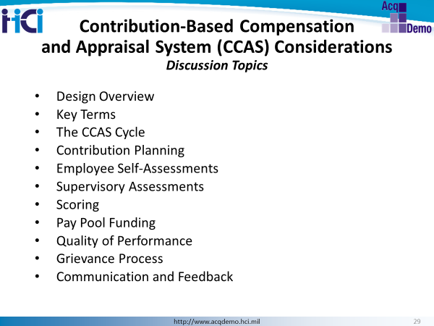

CCAS Design Overview
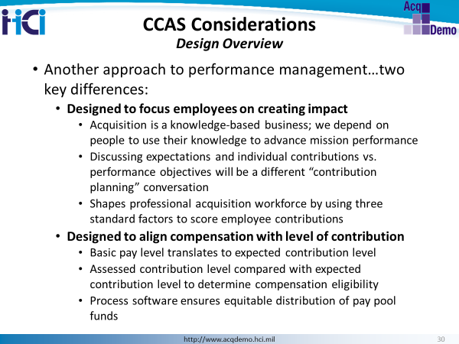

Key Terms
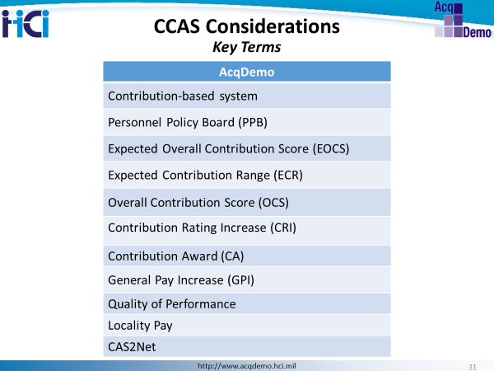

CCAS Cycle
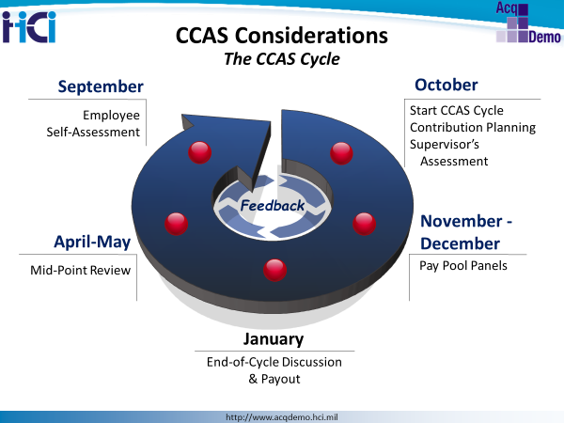

Contribution Planning

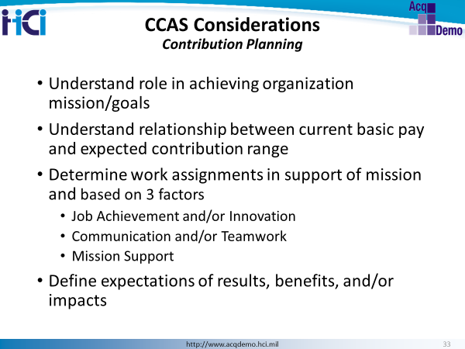

Like any other performance management system, planning the rating cycle work assignments and expectations of them is the key first step.
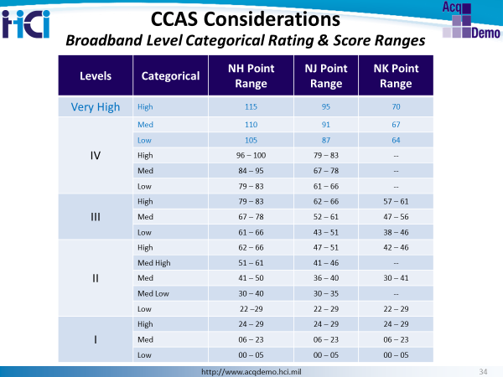
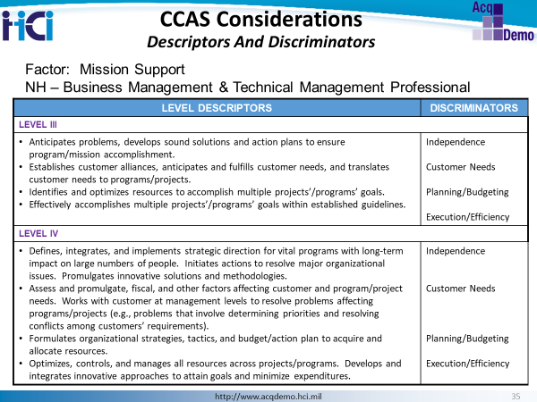
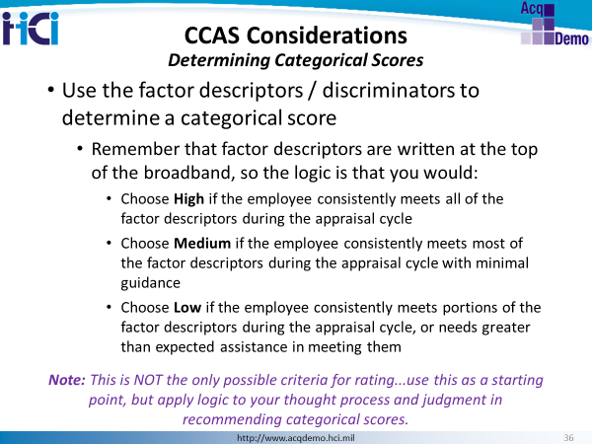

Each employee being the appraisal cycle with an Expected Overall Contribution Score (EOCS), which is based on their basic pay. This places them with a category for which they should target their contributions.
Descriptors

Every factor contains descriptors for each respective broadband level within the relevant career path. The descriptors state what is important to the mission of the organization and describe employees’ contributions at different broadband levels. They were developed at the highest GS grade encompassed in the broadband level to foster employee growth within the broadband level.

Descriptors define increasing levels of contribution for each broadband level. Work performed by individuals in a particular career path is evaluated against the same descriptors, and contribution is determined by a group consensus through the pay pool panel process.

Discriminators

Discriminators refine the factors. They are the same for all levels of contribution. Discriminators include: leadership role, breadth of influence, mentoring/employee development, complexity/difficulty, level of interaction, planning/budgeting, etc.

It is recommended that the pay pool panels meet at the beginning of each appraisal cycle to discuss and reach a common understanding of the factors, discriminators, and descriptors.

Employee Self- and Supervisor Assessments
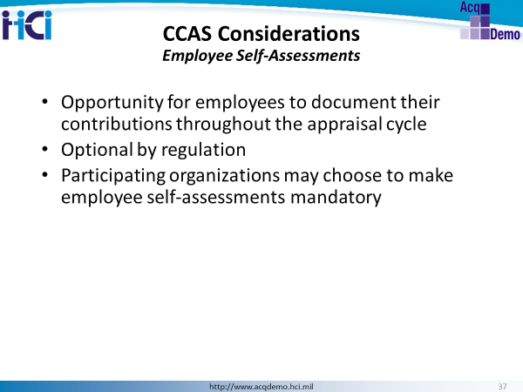
Neither the AcqDemo regulations, nor the AcqDemo Operating Guide, requires an employee to prepare and submit an annual self-assessment. The Participating Organization, however, may choose to make employee self-assessments mandatory.
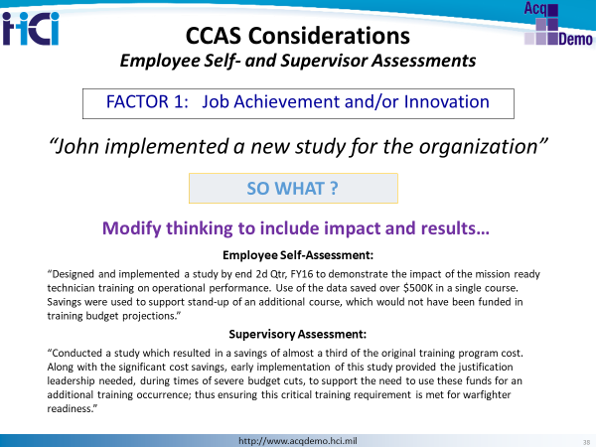
At the end of the appraisal cycle, employees and supervisors will complete self and supervisory assessments. The annual assessments are written to address contributions made throughout the year for each contribution factor. This is an example of addressing the factor, Job Achievement and/or Innovation.
When writing contribution self-assessments, emphasis is placed not on the “what” (activity) and “how” (level of performance) but the “why” (mission) and the “who” (customers)… impact and results.

Scoring
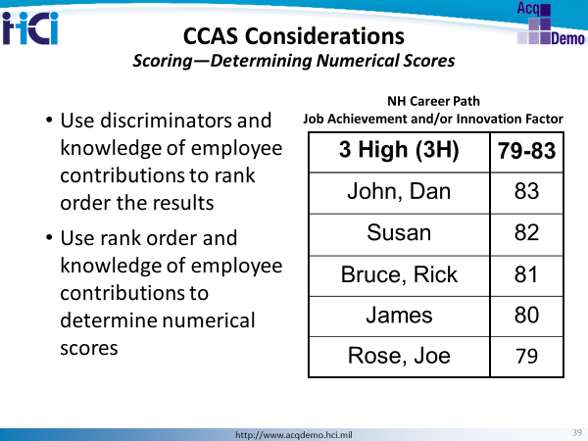
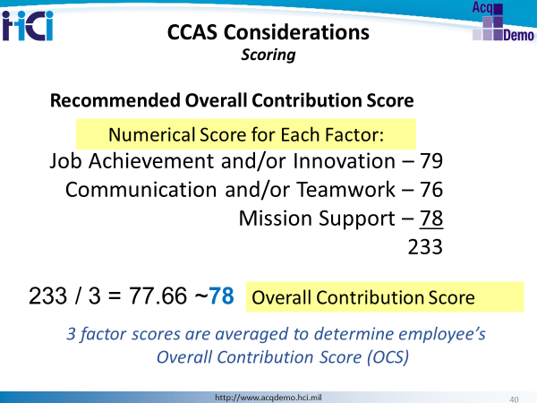
Supervisors will recommend, and pay pools will ultimately approve scores for each factor, which in turn will be averaged and rounded to the nearest whole number to determine each employees final Overall Contribution Score (OCS).

Very High Score
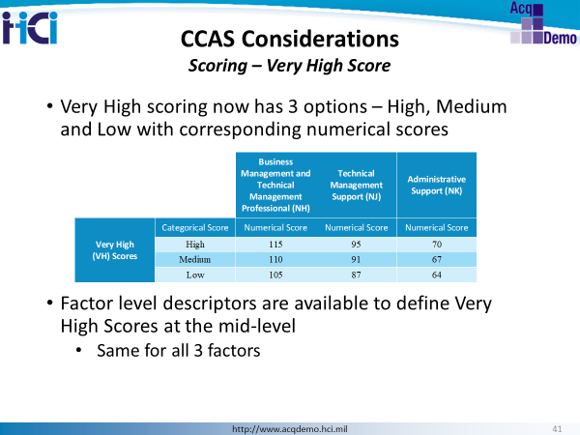

Very high scores are available to recognize an employee for exemplary contributions and overall quality of performance the results of which are substantially beyond what was expected and warrant a score exceeding the top score for the highest broadband level in the employee’s career path.

Very high scores for factors may only be assigned to employees holding a position in NH IV, NJ IV, or
NK III career paths.

Contribution Planning, Employee Self- and Supervisor Assessments, and Scoring Business Rules Decisions

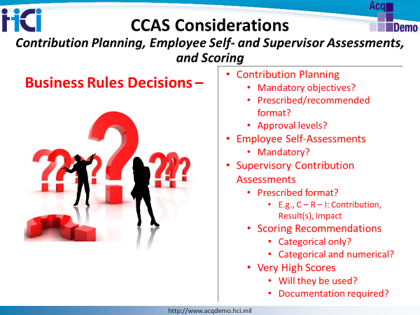

NOTES:

Pay Pool Funding
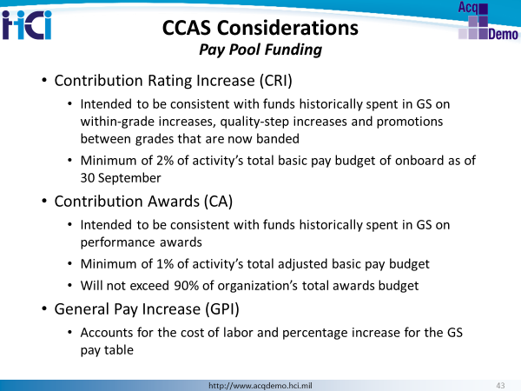
There are three funding elements of AcqDemo. The AcqDemo Program Office will publish a Pay Pool management advisory prior to each year’s CCAS closeout. There may be limitations set for CRI and CA budgets depending on DoD and OPM guidance.

The amount of money available for Contribution Rating Increase (CRI) within a pay pool is determined by the money that would traditionally have been available for quality and within-grade step increases, and career promotions. Funds not distributed from the General Pay Increase (GPI) may also be transferred to the CRI pool of money. Additionally, the CRI pools may be used to augment the Contribution Awards (CA) pool. However, the awards money portion cannot be used for increments to base pay.

The CRI pool of money will be set at no less than 2% of the activity’s total base pay budget. These floors represent a budgetary minimum amount. Components may set higher amounts within their budgetary limits. No ceiling amount is directed by the Operating Guide.

The CA pool includes what were formerly known as performance or bonus awards. This pool will be used for awards given under the CCAS process. The fund will be set at no less than 1% of the activity’s total awards budget. The amount for the CA will not exceed 90% of the 1% for the total awards budget, so as to allow for other awards not related to the CCAS process, e.g., on-the-spot awards and group awards.

The dollar amounts to be included in the pay pool will be computed based on the salaries of the employees in the pay pool as of 30 September each year.

Discretionary Set-Aside
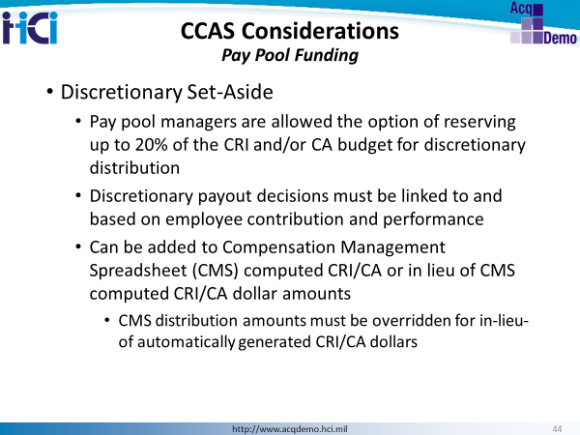
If this option is authorized, it should be noted the amount withheld from the pay pool funds will reduce the overall budget and, therefore, total payouts to all pay pool members.
It is recommended the pay pool spreadsheet (CMS) be allowed to run its algorithms so the results of the ratings can be reviewed first. If certain situations warrant the use of additional (or modified) CRI/CA dollar amounts, then it may be useful to exercise this discretionary set-aside option provided equity in the recognition of contributions is maintained and the distribution of discretionary amounts maintains the integrity of the organization’s compensation strategy and position management structure.

CCAS Reward Payout Criteria
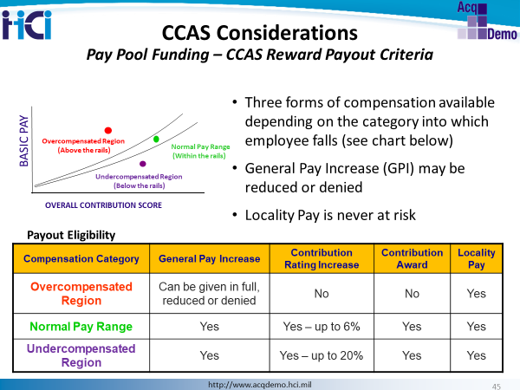
Plotting an employee’s final OCS and current pay on a graph that includes the standard pay line, with upper and lower rails, locates his or her data point into one of three zones, Overcompensated, Normal, or Undercompensated.

Note that Any GPI withheld or denied will roll over into the CRI fund and be redistributed to other members of the pay pool.

Selecting Target Pay
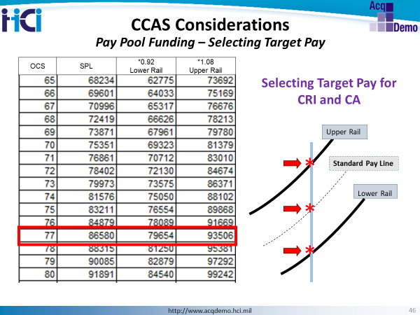
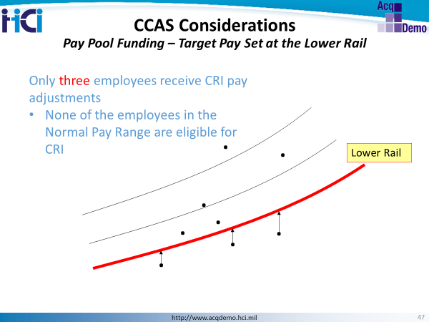
This strategy is rarely used, but effective if most employees are in the Undercompensated region and the compensation strategy is to bring all undercompensated employees into the Normal Pay Range faster in order to achieve pay equity across the pay pool population. Distributing CRI only to undercompensated employees allows larger pay increases to those in the undercompensated region while not increasing any other employee salaries.

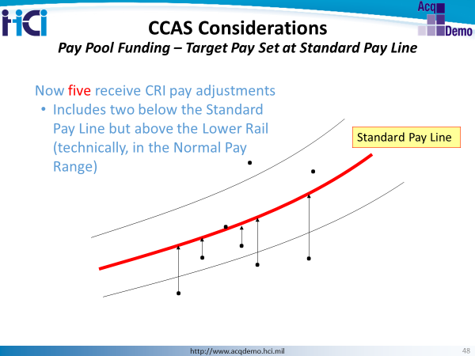
This is the most commonly used option for setting the CRI target. Target pay set at the Standard Pay Line increases basic pay for all those employees whose pay and OCS places them in the Normal Pay Range below the Standard Pay Line and in the Undercompensated Region.
If the Standard Pay Line is also set for CA, only employees plotting below the standard pay line will be eligible for CA as well. Employees whose basic pay and OCS places them in the Normal Pay Range above the Standard Pay Line but below the upper will not be eligible to receive CRI even though their pay is technically considered “appropriate” compensation.
This strategy will result in smaller CRI increases for those who plot below the Standard Pay Line than the increases to those below the lower rail when the target pay is set at the lower rail. This population will be larger than the population at or below the lower rail and, thus, payouts will be more modest in order to move more of the employee population closer to or within the Normal Pay Range (but below the Standard Pay Line).
Employees in the Undercompensated Region will still receive larger CRI amounts than those closer to the Standard Pay Line but smaller than their CRIs when the lower rail is used as the target pay.
This strategy also prevents basic pay increases to those employees within the Normal Pay Range but above the Standard Pay Line (i.e., appropriately compensated). If CRI carryover is allowed, these employees will receive what would be a basic pay increase as part of their lump sum contribution award (CA).

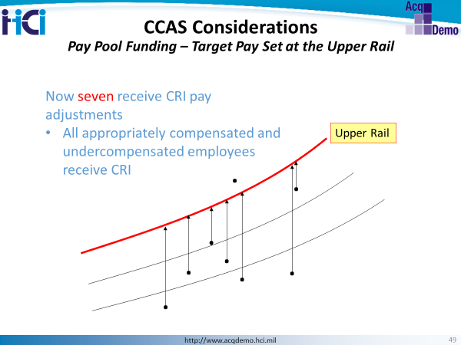
Target pay set at the upper rail allows pay increases to all employees in the Normal Pay Range and Undercompensated Region. This strategy results in salary increases to all employees in these two regions. It is effective for ensuring fairness to all BUT requires a solid compensation strategy and established position management structure to maintain equity; otherwise all employee salaries will float to the top of their broadbands creating pay compression and little room for advancement and growth.
This is often used for setting the CA target rail.

CRI Carryover
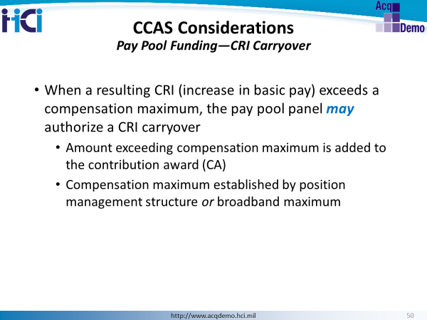
Depending on the category into which an employee’s marker falls, he/she may be eligible for one to three forms of additional compensation. The pay pool panel has the option of awarding the employee up to and including the full General Pay Increase (as authorized by law or the President), a CRI (an increase in basic pay and/or a CRI carryover lump sum payment for the CRI basic pay amount that exceeds a control point in or the maximum basic pay of an employee’s broadband level) and/or a contribution award (a lump-sum payment that does not affect basic pay).

Pay Pool Funding Business Rules Considerations
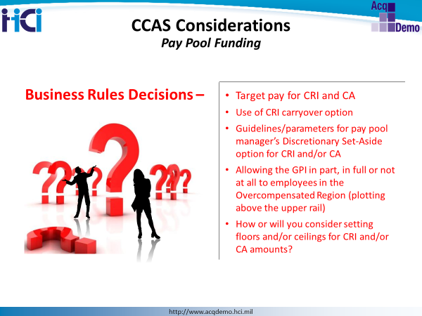
NOTES:

Quality of Performance
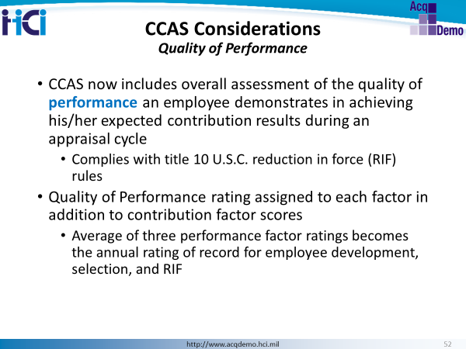
10 U.S.C. §1597(f) requires the determination of which DoD employees shall be separated from employment in a reduction in force to be made primarily on the basis of performance.
The performance level to be assigned to each contribution factor should reflect an employee’s characteristic level of performance during the appraisal cycle as compared to the CCAS factor descriptors and discriminators, expected contribution criteria, an employee’s contribution plan, and the impact of the quality of the contributions on the organization.
A Participating Organization may supplement the generic criteria with additional standards that identify milestones, production, due dates, or other measurable aspects of success contributing to the accomplishment of the goals and objectives necessary to meet an organization’s mission and are achievable during the appraisal cycle.

Quality of Performance Level Definitions
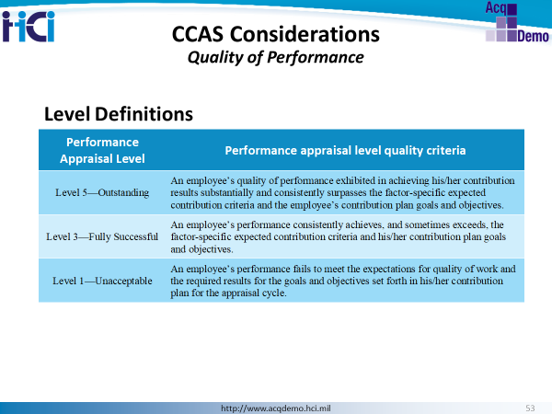
As the rating official considers such items as the employee’s self-assessment, clients’ feedback, and personal observations in preparation for assigning preliminary CCAS categorical scores, he/she will also assess the quality of the employee’s performance in achieving his/her contribution results under each of the three contribution factors. A preliminary performance appraisal level of either Level 5 – Outstanding, Level 3 – Fully Successful, or Level 1 - Unacceptable from Table 3 will be assigned by the rating official to each of the three contribution factors.
The three performance appraisal levels are averaged to calculate the annual rating of record. The resulting quotient will be rounded to the nearest tenth of a decimal point.

Quality of Performance Level Values
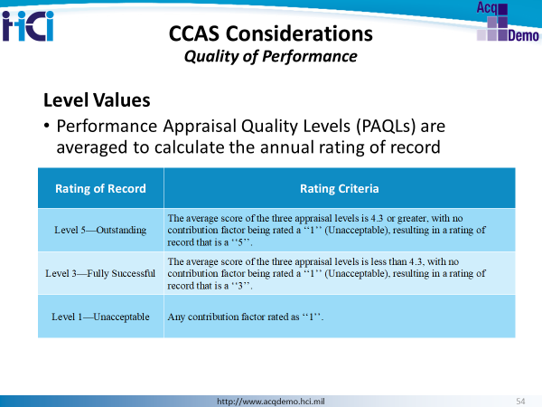
During the pay pool panel process, panel members will review the preliminary performance appraisal level justifications for the contribution factors and rating of record for all pay pool members for consistency and equity of application within the pay pool population before final approval.
The average raw score of the three appraisal levels and the approved annual rating of record will be recorded in the Defense Civilian Personnel Data System.
The annual rating of record will be recorded as a Level 5 - Outstanding, Level 3 - Fully Successful, or Level 1 - Unacceptable.

CCAS Grievance Process
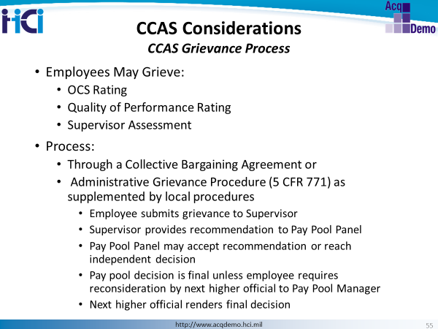
HR Professionals must document and report grievances. Typical timelines are:

- Within 15 calendar days of receiving CCAS Part I (the Overall Contribution Score and Salary/Award payout) the employee will submit the grievance first to the rating official.

- Within 10 calendar days of date of grievance, the supervisor will submit a recommendation to the pay pool panel.
(3) The pay pool panel accepts the rating official's recommendation or reaches an independent decision within 30 days of date of grievance and provides the employee a written decision.
(4) If an employee is dissatisfied with the pay pool panel's decision, within 15 calendar days of receipt of the pay pool’s written decision, he or she may submit a request for reconsideration with the pay pool manager’s next higher official.
(5) Within 60 calendar days of date of request for reconsideration, that next higher official renders a final written and binding decision on the grievance.

Quality of Performance and Grievance Process Business Rules Decisions
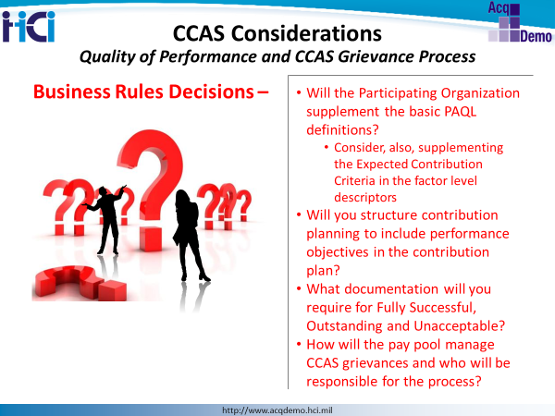
NOTES:

Communicating Aggregate CCAS Results
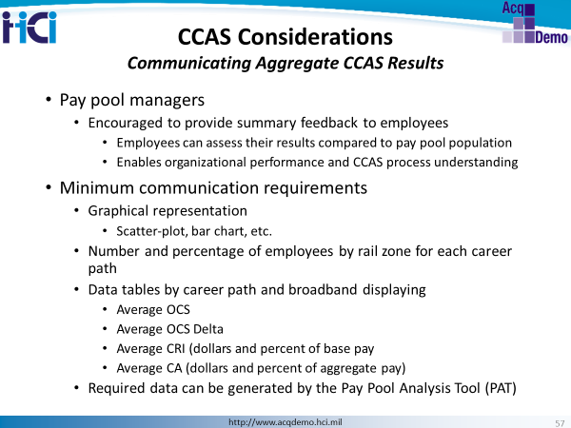
Aggregate pay pool results data is required to be shared with the employees, but the specifics of exactly what is shared is up to each participating organization to determine.
Feedback and communication is a key component of the CCAS process. Providing the workforce with aggregate results will help foster an overall understanding of what is meaningful for the organization’s successful performance and increases the level of understanding and transparency in the appraisal process. Pay pool data maintainers can provide the required data for the aggregate results and in organizations with multiple pay pools, the Superuser can provide multiple pay pool aggregate results.

Continual Feedback and Mid-Point Review
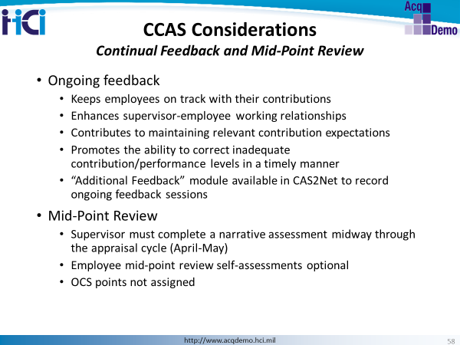
Ongoing supervisor (or designated rating official) and employee discussion during the appraisal cycle of specific work assignments, objectives, contribution expectations, strengths, weaknesses, contribution results, and assessment of the quality of performance within the CCAS framework is essential. This must include discussion of any inadequate contribution and performance in one or more of the factors. If contribution and/or performance is considered inadequate, early steps need to be taken to address the reasons for the inadequate performance and provide appropriate assistance to the employee.
Approximately midway through each appraisal cycle, employees are highly encouraged to complete the mid-point self-assessments and supervisors will complete a mid-point narrative assessment. The supervisor will not assign any scores to the mid-point review. The supervisor will meet with the employee to discuss progress of the contribution plan, areas needing improvement, assistance available, and expectations for the remainder of the cycle. The supervisor must document the mid-point review discussion by entering the date and method of communication in CAS2Net.
An Additional Feedback module allows the supervisor to provide helpful guidance throughout the contribution-rating period. An Additional Feedback paragraph in the organization’s business rules should include examples of why supervisors would want to use this module such as documenting declining performance and suggestions on how to improve. Constant communication will eliminate blindsiding the employee with a poor assessment at annual appraisal time.

Closeout Assessments
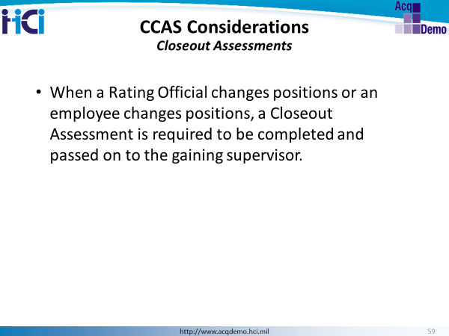
A partial closeout is prepared upon a change of supervisor and is not to be used in lieu of the annual assessment. A closeout enables the employee and supervisor to document contributions for partial year position assignments, but will not include any scores. There are no minimum periods for a rating official to complete a closeout.
When the supervisor/rating official leaves before the end of the appraisal period, the departing supervisor/rating official will complete a closeout assessment in CAS2Net and discuss the closeout assessment with the employee. The supervisor must document the closeout discussion to include entering the date and method of communication in CAS2Net. The departing rating official may prepare a Mid-Point Review in lieu of a closeout if departing during the time period designated for Mid-Point Reviews by the organization.
The AcqDemo regulations do not set any minimum time period for supervisors to complete a closeout assessment when the prescribed circumstances require one.

Communication and Feedback Business Rules Decisions
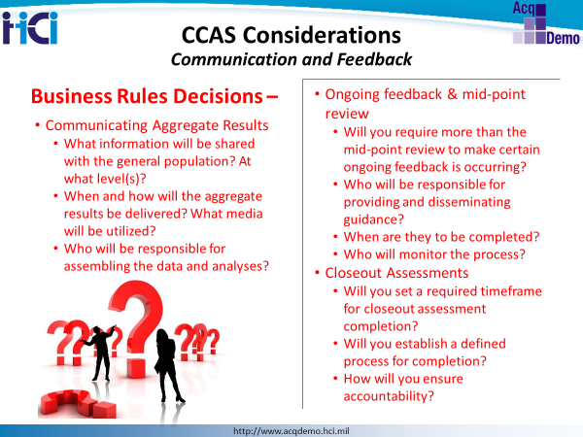
NOTES:

